**Applying for A level Graphics at Loreto 6th Form College without the entry requirements (Art and Design GCSE)**

**The Research Task:**

Select one artist, illustrator or designer for inspiration. Please focus on artist, illustrators and designers that are recognised for their achievements beyond a social media presence. Produce a short piece of writing presented in your choice of format (eg. Word doc, PDF, PowerPoint, Canva). Provide a brief overview of your artist, illustrator or designers practice, then briefly analyse an image. What is your opinion of their work and the ideas behind it?

**The Practical Task:**

Create can either create a series of drawings by hand or digital illustrations, a minimum of 5, a logo including initial sketches to final design. Or create a series of photographs (and edit if applicable) 10 – 15 images to demonstrate your enthusiasm and ability. We are looking for an awareness of composition and creativity in your images.

You should see either the Head of Department, or a member of the graphics teaching staff to assess your suitability for the course.

**Examples:**

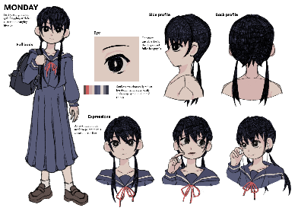

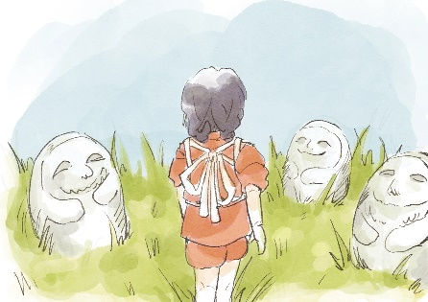 Example of a character sheetExample of initial sketches

Example of ipad illustration Example Logo ideas