Applying for A level 3D Design at Loreto 6th Form College without the entry requirements
Students wishing to enrol onto 3D design are normally expected to have achieve a minimum of a grade 5 in either an Art and Design subject or Design Technology.
We are aware however, that these subjects are not aways available when pupils choose their options at the end of year 9. We also understand career plans change in years 10 and 11. In this instance we ask potential 3D design students to undertake a making and a research task. This is so that we can be assured that potential students have the correct skills, attitude, and determination to be successful on A level 3D design at Loreto 6th Form.
We ask that potential students have undertaken a GCSE equivalent course in Engineering also complete the making and research task. This is because some students with this type of qualification have struggled to complete the A level in 3D design, this is because the 3D Design course at Loreto sits within the art and design curriculum.
The Making Task
Please refer to the images below. These are examples produced by 3D design students in the early months of the course. We ask that potential students construct a piece of paper engineering. This could be inspired by the images below. However, as the course is creative, we would like to see the creativity of potential students. The images below are for reference only, we do not expect this amount.
You may wish to visit Pinterest or YouTube for ideas.

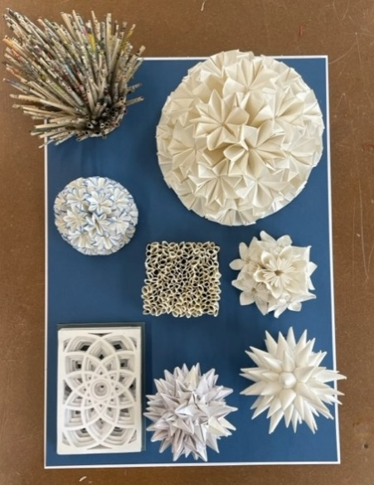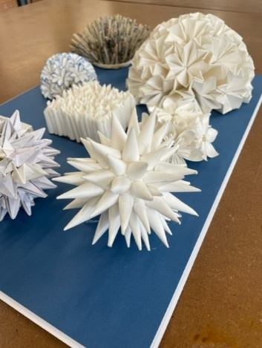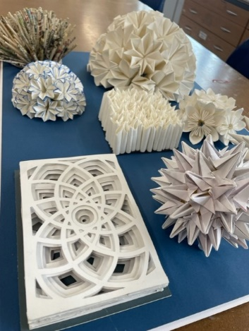

The Research Task
We ask students to research a designer. This could be an architect, a product designer, a furniture designer, a crafts person. Please focus on designer that is recognised for their achievements beyond a social media presence. We ask that you prepare a short piece of work presented in your choice of format. We ask that you provide the relevant information about your designer, but we are also looking for you to analyse a piece of their work. What is your opinion of their work?
What next?
Once students have completed these tasks, they should photograph their artwork and submit it alongside the research task via email to 3ddesign.portfolio@loreto.ac.uk. The teachers from 3D design will then confirm your place or offer advice.

